Newsletter
Respect, Compassion, Responsibility, Courage
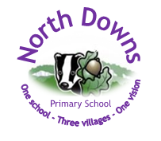

Date: 3rd October
Term: Autumn 2025
Issue No: 3
Be the best you can be, every day

Dear Parents, Carers and Children
As we gallop rapidly though this this half term, we would like to share with you yet another Newsletter, packed with information, reminders and updates. Firstly, a request – we would be grateful if you could discourage your children from bringing in any toys from home, big or small. Not only are they proving a distraction from learning in class, there is much sadness when something is lost or broken – which often happens. We would appreciate your support in this matter.
Parent Teacher Consultations
This term’s Parent Teacher Consultations are planned for Tuesday 21st October from 4.30pm – 7.00pm and Thursday 23rd October from 3.30pm – 6.00pm. Appointments will be bookable online, via Scopay, from 12.00 noon on 12th October. Booking instructions have been sent out with this Newsletter. As explained previously, we are introducing a change to the format of the meetings by holding them all at the Brockham site – we are hopeful this will be more convenient for parents. The organisation for the evenings will be as follows:
- Parents are asked to arrive before their appointment time and enter by the main gate (near the Brockham Office).
- Teachers will be available to meet with parents in the school hall at the designated appointment time.
- A bell will ring every 10 minutes to mark the end of one appointment and the start of the next. Please keep to your allocated times and be kind to the next set of parents by leaving promptly when the bell rings for the next appointment.
- Please note these meetings are for parents only.

Sporting Successes…

Dorking Schools Cross Country
On a gloriously sunny afternoon this week, the Dorking Schools held their first Cross Country competition of the season at The Weald School. North Downs had 52 girls and boys from Years 3 - 6 competing. It was a really exciting event and our teams had great fun and performed extremely well. We had many outstanding performances in the Individual competition with the following in the top 10 finishers for their age group:
Year 3/4 Girls: Reya – 2nd
Year 3/4 Boys: George W 2nd, Jenson 4th and Seb Y 7th
Year 5/6 Girls: Imogen 2nd, Grace N 4th and Poppy G 6th
Year 5/6 Boys James K 2nd, William 4th, James W 7th, James S 8th Kellan 9th and Stanley 10th
In the team event, our Year 3 and 4 Girls were 3rd and our Year 3/4 Boys, Year 5/6 Girls and Year 5/6 Boys all finished in 1st place. Congratulations to all our amazing runners!

Newdigate Cricket Prize Giving!

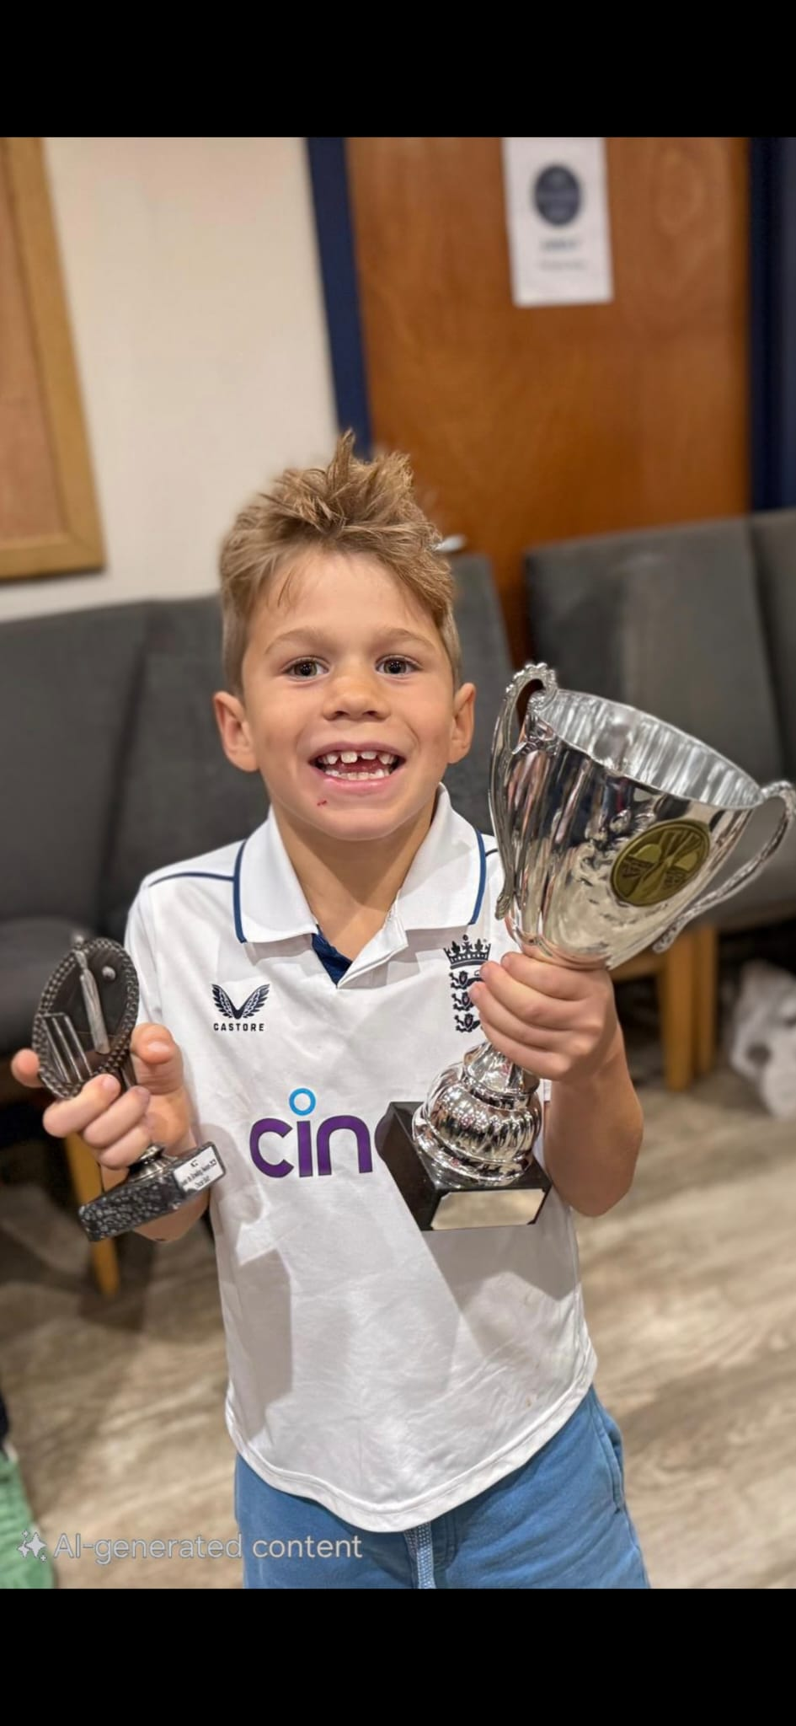
From our Year 5:
Kellan -
won best fielder U9s
Harris -
won best batter U9s
George -
won best Bowler U9s
Oscar -
in Year 3, won best Bowler in the U8s (playing a year up!)
Congratulations boys!

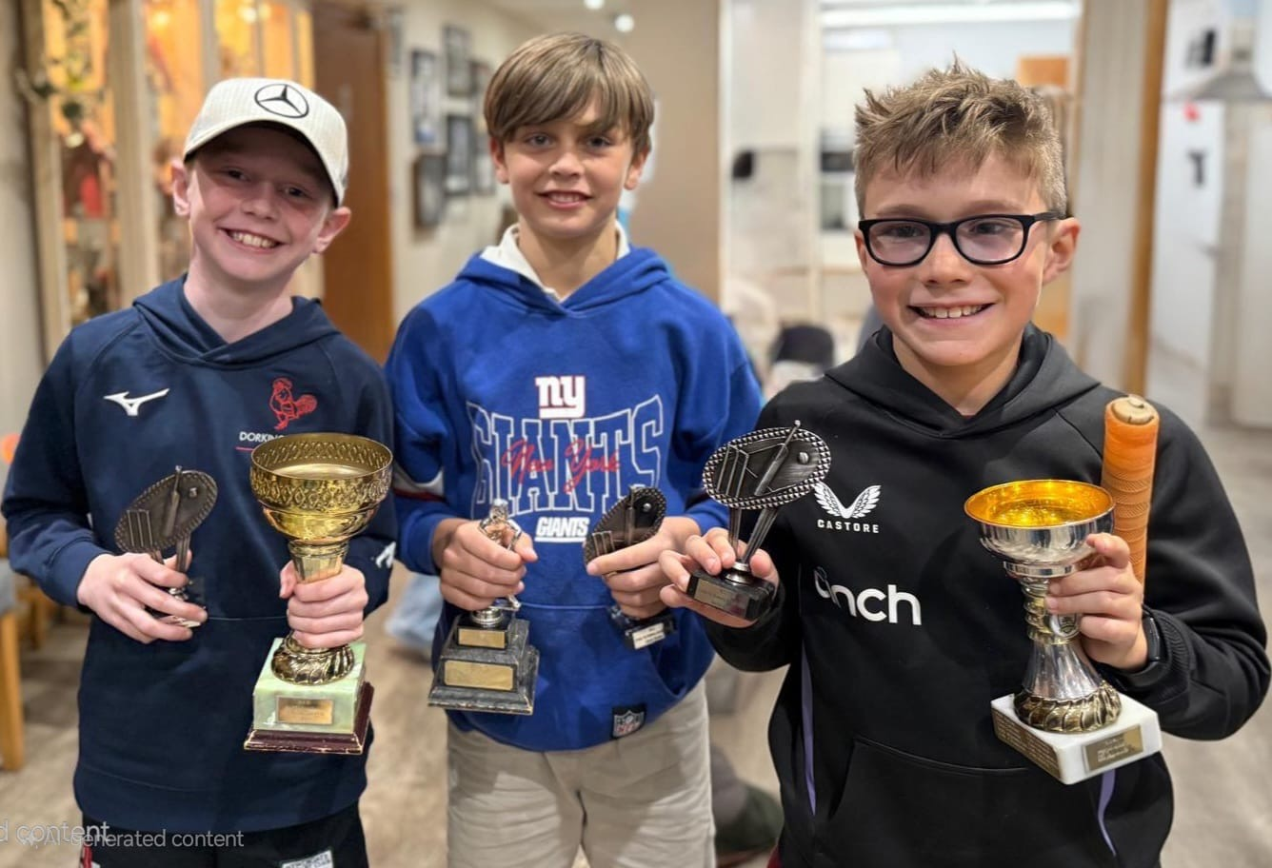

Wishing you all a relaxing and enjoyable weekend.
Changing Rooms Update
We last updated you in the Summer Term about the work we are doing to replace the swimming pool changing rooms.
We submitted an application to Mole Valley Council to carry out the work as a permitted development. They wrote to us at the beginning of the summer holidays to tell us that this application was not successful and they advised us that we should submit a full planning application instead.
Last week we submitted that application. In the interim, we have had formal quotations from a number of modular building companies and once we have the planning agreed, we are ready to award a contract to one of those and move forward with the works.
We will update you again once we have some more news!

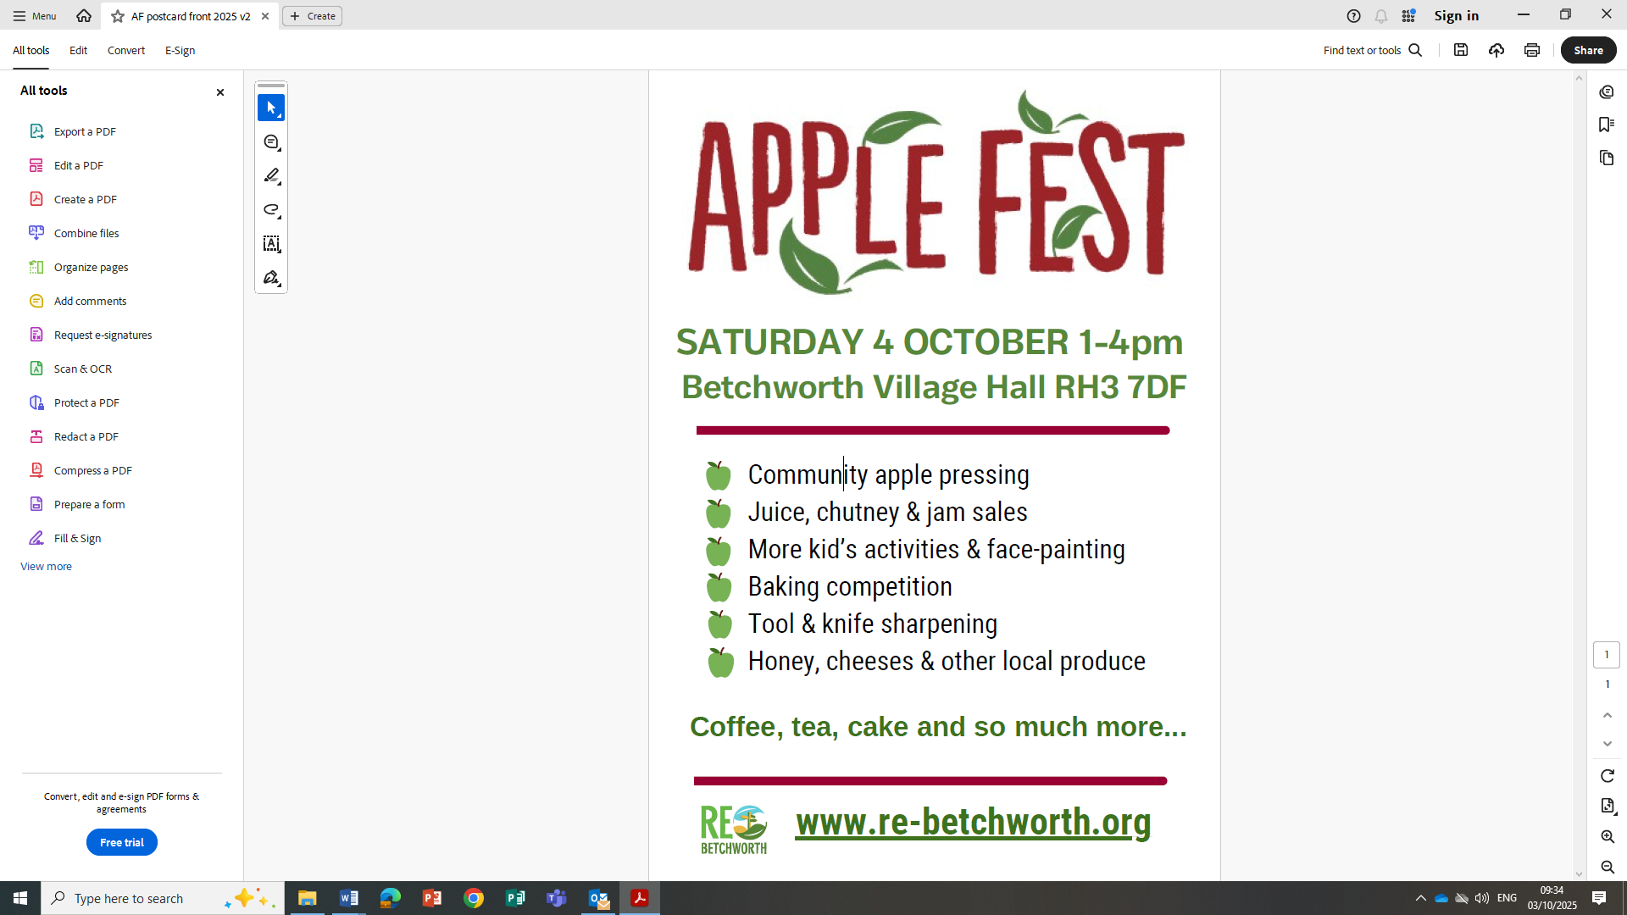
World Mental Health Day
We are celebrating ‘World Mental Health’ Day on Friday 10th October. For our whole school homework next week we have asked that children…on an A4 piece of paper, draw, photograph, describe, use technology or paint: What makes you happy?
This will be added to a whole class book for our reading corner/displays so please DO NOT stick your sheets of paper into the homework book! We would also like to invite the children to wear something yellow on that day to represent positivity.
Dates for the Diary
Friday 10th October – World Mental Health Day – wear something yellow
Monday 20th October – Individual Photos at Brockham
Tuesday 21st October - Individual Photos Leigh and Betchworth
Tuesday 21st October - Parent Teacher Consultations
Thursday 23rd October - Parent Teacher Consultations
Friday 24th October – Break up for Half Term
Monday 3rd November – INSET Day
Tuesday 4th November – Children return to school
Tuesday 9th December– Year 2 Nativity
Wednesday 10th December – Junior Christmas Carol Evening
Thursday 11th December – Year 1 Nativity
Friday 12th December – Year R Nativity
Wednesday 17th December – School Christmas Lunch
Friday 19th December – Break up for Christmas

‘Futures Fridays’
On Friday 12th September, one of our lovely parents (and local celebrity), Mrs Budd kindly kicked off this year’s ‘Futures Fridays’ assemblies. Hot off the press of featuring on the BBC (other media channels are available!), she presented a brilliant assembly about life as a cattle farmer. The assembly also linked to British farming week encouraging people to support local businesses.

A huge thank you Mrs Budd who also delivered the assembly at our Leigh site too. Once again, if anyone feels they could volunteer to present an assembly about their career, we would love to hear from you. Please let us know on the gate or via info@northdowns.surrey.sch.uk



